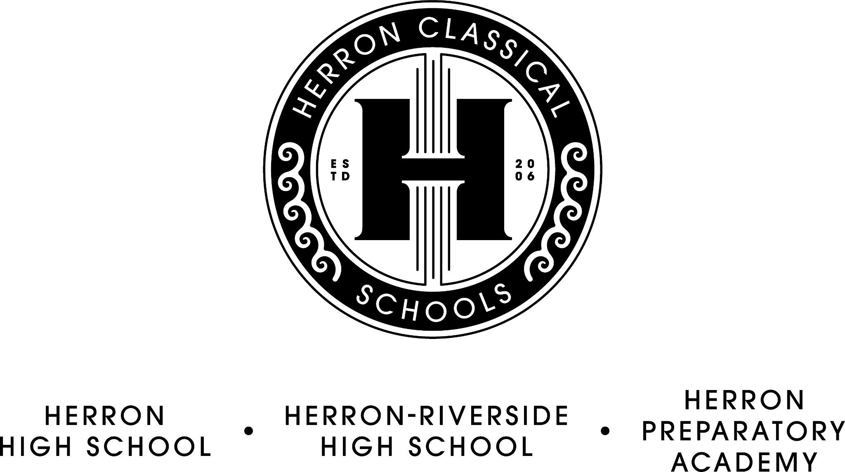

Herron Classical Schools Board Meeting Agenda
February 21st, 7:30am
Herron Classical Administration – former Merchants Insurance building, 1715 N. Meridian Please park in the lot on the north side of the building and enter at the front door. The parking lot is accessible from the alley.

Agenda

Meet and Greet with Casey Osterkamp, HCS VP - Operations

- Call meeting to order (Roy)

- Approve minutes (Sullivan)

- Executive Committee report (Roy)
- Facilities update

- Treasurer’s report/Fiduciary Committee report (Miller)
- Financials
- Vouchers

- Development Committee report (Sternberg)
- Department updates

- Education Committee Report (Roy)
- 2023 Enrollment update
- Spring state testing academic supports
7). President’s Report (McNeal)
- Indy Charter Leaders meetings
- Former Merchants Insurance building plans and tour

Adjourn

The next board meeting will be the annual retreat on April 18, 7:30 AM

